Guidance for Early Help &Support (EH&S) and Enhanced Children &; Families (EC&F) Teams
Purpose
This guidance has been developed to further clarify and streamline processes within the new model. Details are provided on the provision of both teams, and the referral form has been further developed. This will be required to be submitted to the SWCC (sw.contactctr@fife.gov.uk)
The following information is a guide to support a better understanding of the factors to consider when making a referral to the Children & Families Service. Its aim is to offer support for practitioners in assessing an unborn baby/child/young person’s (UBB and C&YP) level of need and to consider what type of services/resources may meet these needs. This guidance also details what processes to follow if the assessment indicates the need for a social work service.

The Model
The model is based on a one service approach with Early Help & Support (EH&S) and Enhanced Children & Families (EC&F) Teams. There are 7 EH&S and 7 EC&F teams. The principles listed below align to the whole service including specialist teams within the C&FS
- Child focused
- Non-discriminatory
- Strength based and trauma informed
- Whole Family
- Non stigmatising
- Inclusive and participative
- Rights based
- Empathetic & compassionate

A summary of the core components of the EH&S and EC&F teams are detailed below.
Early Help & Support Teams
The aim of the EH&S teams is to offer a range of support for children and families in need to promote wellbeing and developmental needs through a whole family approach. Prior to referring ,services should offer support to families to access universal services including Third sector support available locally (considering the 5 GIRFEC questions), which will determine if early help and support is required based on a robust assessment.
EH&S teams will provide initial assessment and support underpinned by a whole family approach for

- 1-1 support in family homes underpinned by a family decision making approach
- Delivery of group work with partners (e.g. Incredible Years, Mellow, Triple P and more)
- Pre-birth support and assessment if needed
- Collaborative work with Primary & Secondary Schools
- Collaborative work with Health Visiting Teams, CLD and Third sector organisations
- Development of community initiatives based on themes and local need
- Support transitions to the new prevention and wellbeing service -No Wrong Door once operational
- Support transitions to universal or Third sector services
- Every effort will be made to scaffold support around children and families however where parents/carers are unable to sustain change this will require a supported transition for enhanced support and assessment from EC&F.

Enhanced Children & Families Teams
The aim of the EC&F Teams is to address concerns and risks factors which may require consideration of both child protection or, compulsory measures of care for C&YP .
EC&F teams will provide initial assessment underpinned by a whole family approach based on EC&F Team criteria. They will

- Lead for children’s planning for C&YP subject to a Compulsory Supervision Order at home, foster care, kinship care, residential care including secure placements
- Identify, assess and manage risk
- Safety Planning for C&YP at risk of significant harm
- Complete parenting capacity assessments to support care planning.
- Coordinate family time and sibling contact.
- Pre-birth assessment
- Permanence Planning
- Support reunification of children within their family network
- Review plans leading to potential for reunification of families
- Targeted 1 -1 and group work for example parents affected by harmful substances, young people entering the justice system.
- Support transition to the EH&S or other relevant services

The Process
It is important that all agencies understand the needs of each individual UBB and C&YP within their own context and that each situation is unique and specific to them. Assessment practice underpinned by the National Practice Model and applying the 5 GIRFEC questions is the agreed partnership approach to ensuring good quality assessment and timely support is in place to address wellbeing needs, concerns, and risks. Partnership awareness of the range of support services in localities is important to ensure support is accessed and available to respond to wellbeing needs early.
It is only by completing an assessment and chronology that practitioners can gain a clear understanding of a UBB and C&YP level of need and risk and what would be the appropriate service response.
Prior to making a referral for support it is expected that the named person in universal services will have carried out an assessment applying the 5 GIRFEC questions.
- What is getting in the way of this child’s wellbeing?
- Do we have all the information we need to help this child?
- What can we do now to help this child?
- What can my service do to help this child?
- What additional help, if any, may be needed from others

For any request for support, it would be expected that:
- In advance of making a referral the named person (or lead professional) will have discussed the proposal with the child, young person and/or family, unless doing so would place a child or young person at significant risk of harm
- Requests for group work will be assessed to establish if this type of intervention is required and will be influenced by timescales for group work delivery. If an IY group is requested the Strength & Difficulties questionnaire should be completed by the referrer to inform the referral.
- The attached referral form should be completed and submitted to the Social Work Contact Centre where it will be recorded on our electronic recording system and passed to the relevant team based on the criteria above. A child’s plan and chronology should also be submitted with the referral to avoid any delay.
All referrals are to be made via the Social Work Contact Centre (SWCC) where screening is undertaken.

Response on receipt of a referral
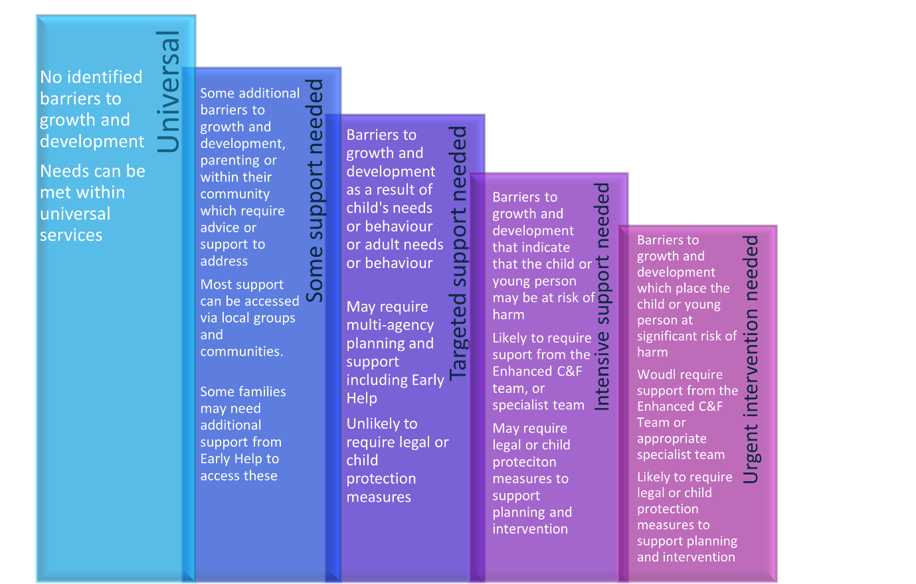

When the social work practitioner in the SWCC receives a referral, they will undertake the following :
- Check social work records to determine any current or previous service involvement.
- Discuss the referral with the referrer.
- Discuss the referral with the named person if available.
- Discuss with the family – unless this would lead to a child protection concern.
- Decide on next steps and whether the criteria for EH&S or EC&F is met, options include:
There can be a number of responses following submission of the referral.
- No further action
- Provision of advice and guidance.
- Further information is required to be submitted to the SWCC
- Transferred by the SWCC to EH&S for consideration of assessment.
- Transferred to EC&F
- Transferred to specialist team

Referrals to the SWCC are screened on the day they arrive. Timescales are dependent on the information provided on the level of need/vulnerability/risk included within the referral. Referrals screened as highest priority are allocated at the time of referral and will be prioritised for assessment. All others should be completed within 20 working days. The named person will be notified by the SWCC, EH&S or EC&F team of the outcome of all referrals and the reasons for the recommendation.
Where there are concerns that an UBB and C&YP may have been abused or may be at risk of significant harm, child protection processes should be initiated. A core agency i.e., Health, Police or Social Work can raise an IRD which will start the formal process of information sharing, assessment, analysis, and decision making. Single agency guidance is available and should be followed.
Additional Information to support relevant referrals
- A further referral to the SWCC is not required for children/young people with an allocated worker if there are further incidents or growing level of risk. If the child/young person has an allocated worker contact the worker directly, or duty worker if unavailable. Note incident and actions in chronology. This will be assessed based on the information provided. This could reach one of the following outcomes: (1) - due to the level of concerns further assessment is required and discussions will he held within the relevant EH&S or EC&F Team (2) the worker determines ongoing support is appropriate and proportionate.

Referral Form and Contacts

- Police Scotland will continue to use the Vulnerable Person’s Database (VPD) system.
- The EH&S and EC&F Team duty number or email are operational from 8.48 am – 5.00pm Monday - Friday, EOOHS from 5pm and public holidays. Duty numbers and email addresses for EH&S and EC&F Teams are in this link:

